Workbook:
6 Ways to Work Smarter,
Not Harder
Streamline your tasks, maximize your efficiency, and make the most of your time.

Introduction
Welcome to the 6 Ways to Work Smarter, Not Harder Workbook

In today’s fast-paced world, being busy doesn’t always mean being productive. The key to real progress is working smarter, not harder. This workbook is designed to help you streamline your tasks, maximize your efficiency, and make the most of your time, all while reducing stress and avoiding burnout.
Throughout this workbook, you will discover practical strategies to enhance your productivity, including prioritizing tasks, mastering delegation, grouping similar tasks, leveraging technology, and breaking down big projects. Each section includes reflection questions to help you assess your current habits, actionable steps to implement immediately, and follow-up exercises to track your progress.
By the end of this workbook, you will have the tools and techniques needed to get more done and create a sustainable routine that allows you to focus on what truly matters.
So, let’s dive in and start working smarter—your time and energy are worth it!

Section 1: Prioritize with Purpose
Reflection Questions:
- What are the three most important tasks you need to complete this week? Why are they important?
- Are there tasks on your to-do list that could wait or be delegated?
Action Step:
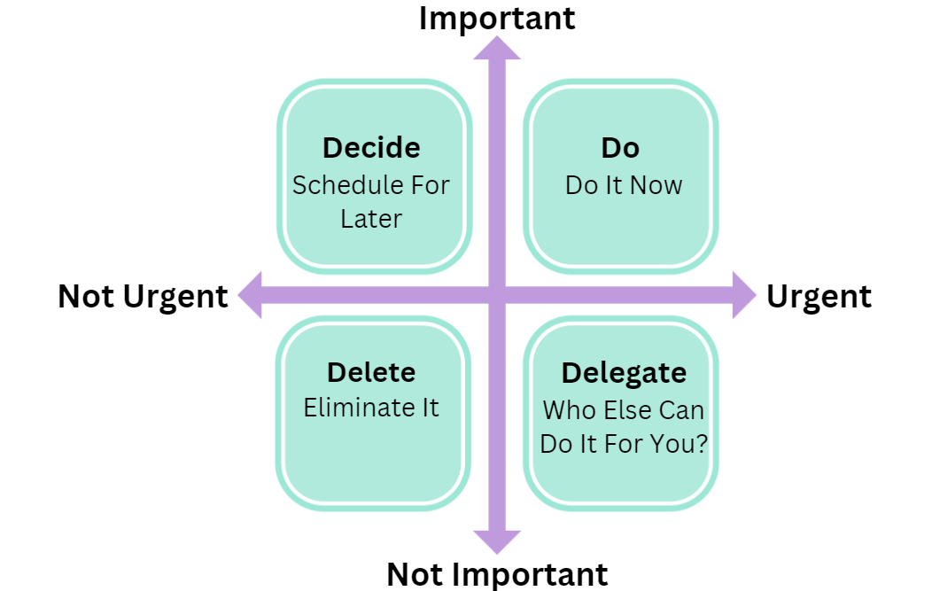
- Eisenhower Matrix Exercise: Draw the Eisenhower Matrix and categorize your tasks based on urgency and importance. Place each task in one of the following quadrants:

Follow-up:
- Which tasks did you identify as high priority, and how will you approach them this week?

Section 2: Master the Art of Delegation
Reflection Questions:
- What tasks in your daily routine are repetitive and take up most of your time?
- Are there tasks that someone else could handle more efficiently?
Action Step:
- Delegation Plan: List 3 tasks you can delegate (personal or professional). Write down who could take over each task and a deadline for handing it off.
Task # | WHO CAN TAKE OVER | DEADLINE FOR HANDOFF
TASK #1
TASK#2
TASK #3

Follow-up:
Set a date this week to delegate these tasks. Track how much extra time you have once they are off your plate.

Section 3: Group Tasks for Maximum Efficiency
Reflection Questions:
- Which tasks in your day could be grouped together?
- How does switching between unrelated tasks affect your focus?
Action Step:
- Task Batching Exercise: Identify 3 categories of tasks that you can group, and schedule dedicated time blocks for each. (ex. Emails, Phone Calls, Creative Work)
CATEGORIES | DEDICATED TIME

Follow-up:
- Track how much time you save by batching these tasks. Reflect on your focus and productivity levels after a week.

Section 4: Leverage Technology and Automation
Reflection Questions:
- Are there any tasks you do manually that could be automated with technology?
- What apps or tools could make your workflow more efficient?
Action Step:
- Automation Plan: List 3 areas where you can implement technology or software to streamline your work.
AREA #1
AREA #2
AREA #3

Follow-up:
- Choose one automation tool to integrate into your routine this week. Reflect on how it improves your workflow.

Section 5: Break Big Projects into Manageable Steps
Reflection Questions:
- Have you ever felt overwhelmed by a large project? What was your approach?
- How could breaking it into smaller tasks make it more manageable?
Action Step:
- Project Breakdown: Choose a current project you're working on and divide it into 5 smaller, actionable tasks. Write down the timeline for completing each.
CURRENT PROJECT | ACTIONABLE TASKS
1.
2.
3.
4.
5.
1.
2.
3.
4.
5.
1.
2.
3.
4.
5.
1.
2.
3.
4.
5.
1.
2.
3.
4.
5.
Follow-up:
- After completing these smaller steps, reflect on how breaking down the project affected your motivation and progress.

Section 6: Take Breaks to Recharge
Reflection Questions:
- How often do you take breaks during the day? Do you feel more or less productive afterward?
- What activities help you recharge and clear your mind?
Action Step:
- Pomodoro Exercise: Implement the Pomodoro Technique for one workday. Set a timer for 25 minutes of focused work, followed by a 5-minute break. Repeat 4 times, then take a longer break.
FOCUS LEVELS | HOW DO YOU FEEL AFTER THE BREAK?

  - Track your focus levels during each session.
  - Note how you feel after each break.
Follow-up:
- Did you feel more focused and productive by using breaks effectively? How can you incorporate more strategic breaks into your daily routine?

Summary: Working Smarter Reflection
Final Questions:
- Which of the six strategies had the biggest impact on your work routine?
- How has working smarter, not harder, changed the way you approach your tasks?
Next Steps:
- Create a weekly plan using at least 3 of the strategies from this workbook. At the end of each week, review your progress and adjust your approach.

